Operation Heroes Connect Youth Summer Camp Facilitator Application and Agreement

Name: ____________________________ Today’s Date: _________________
Birth Date: __________
Home Address: _______________________________________________________________________
Street Address City State Postal Code
Home Phone No: __________________________ E-mail Address: _____________________________
Affiliation/Employer: ___________________________ Title/Position Held: ______________________
Work Address: _______________________________________________________________________
Street Address City State Postal Code
Work Phone Number: __________________________ E-mail Address: __________________________
Supervisor’s Name: _______________________________ Years at current employer: _____________
Does your employer promote volunteer activities? _______________________________________________
If yes, please explain (optional): _____________________________________________________________

Please indicate below if you are willing to approach your company about any of the following opportunities:
_____ Mentoring Opportunities _____ Other in-kind goods/services ___ Corporate Sponsorship
Previous Employer (if less than 3 years at current position): ____________________________________
Address: __________________________________________ Years at this employer: _______________
Education and Training:
High School Attended: _____________________________________ Year of Graduation: __________
College Attended: _________________________________________ Degree: ____________________
Other Education and/or Special Training: ___________________________________________________
Do you speak any languages other than English? _____ If so, please indicate which: ____________
Volunteer Experience
Please List prior Volunteer Experience:
_______________________________________________________________________________
Have you applied to be a facilitator with Operation Heroes Connect in the past? __ N __ Y
If yes, when? ___________________________________
Application Questions
Your responses will help us determine your fit for the summer camp facilitator role and how you can contribute to the Operation Heroes Connect Summer Camp.
Describe any previous experience you have in facilitating, mentoring, or working with youth groups.
What qualities, skills, or other attributes do you possess that would enrich our youth summer camp? Please elaborate.
What do you anticipate being the most challenging aspect of being a summer camp facilitator?
What personal growth or fulfillment do you hope to achieve through this experience?
Do you have any preferences or special skills in particular camp activities or workshops? (e.g., sports, arts, STEM)
Are there any conditions that may affect your participation in the camp program? __Yes __No. If yes, please specify.
How did you learn about the Operation Heroes Connect Youth Summer Camp opportunity?
Are you interested in specific themes or activities for the camp based on your past experiences or expertise?
References
Please list three (3) non-relative references known for at least one (1) year. Include complete contact details. References will be confidentially contacted.
Name: __________________________________ Relationship: _______________________
Phone Number: __________________________ Years Known: _______________________

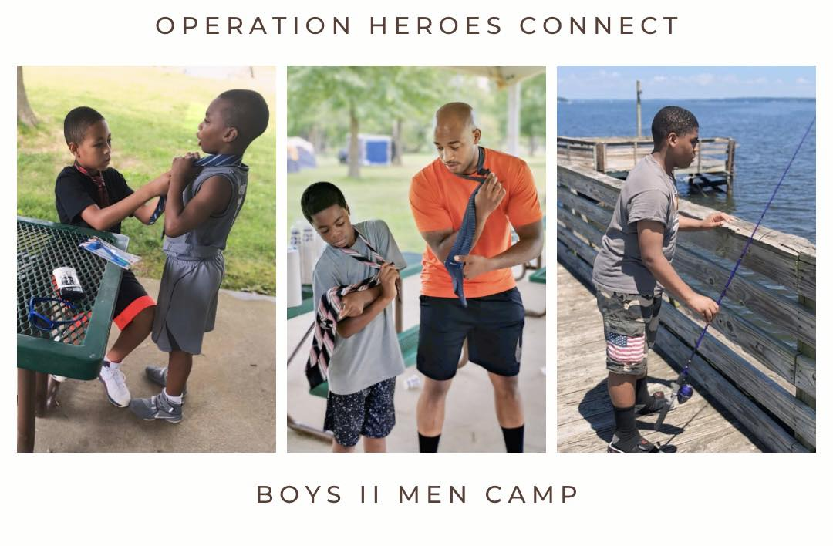
Mission Statement: Operation Heroes Connect is a non-profit organization that provides support, resources, and mentorship to military service members, veterans, and their families. The organization's programs and initiatives are designed to help address the unique challenges and sense of unfulfillment faced by many transitioning veterans by allowing these veterans to continue to give back in a huge way as counselors, mentors, and camp facilitators to youth in the D.C, Maryland, and Virginia areas. Through our community engagement programs, the organization also provides a platform for veterans to reconnect and share their experiences with one another.
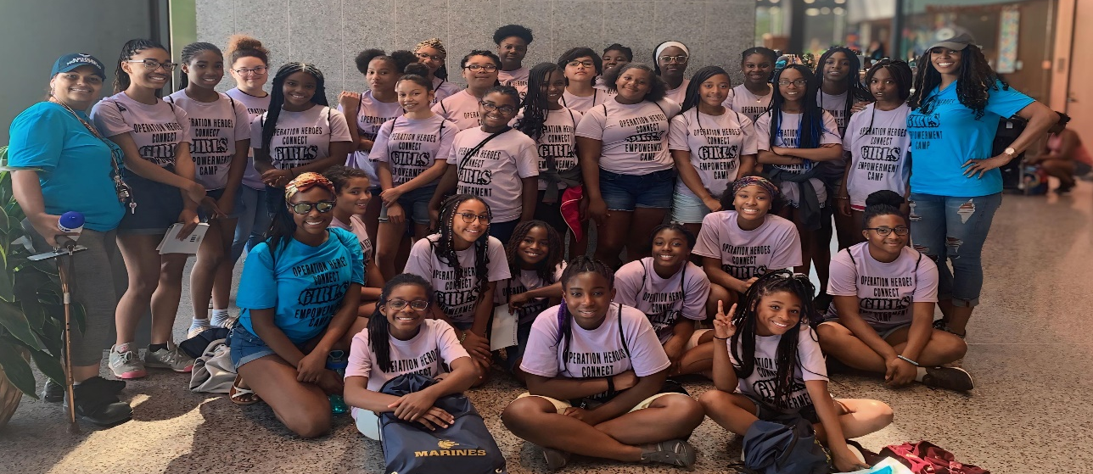

As the founder of Operation Heroes Connect, Tee Marie Hanible, a Marine Corps Retired Gunnery Sergeant and a former foster child herself, understands the profound impact of mentorship and support on young lives. Tee's personal journey fuels her passion for empowering children and providing them with the same love, guidance, and opportunities that shaped her own path to success.
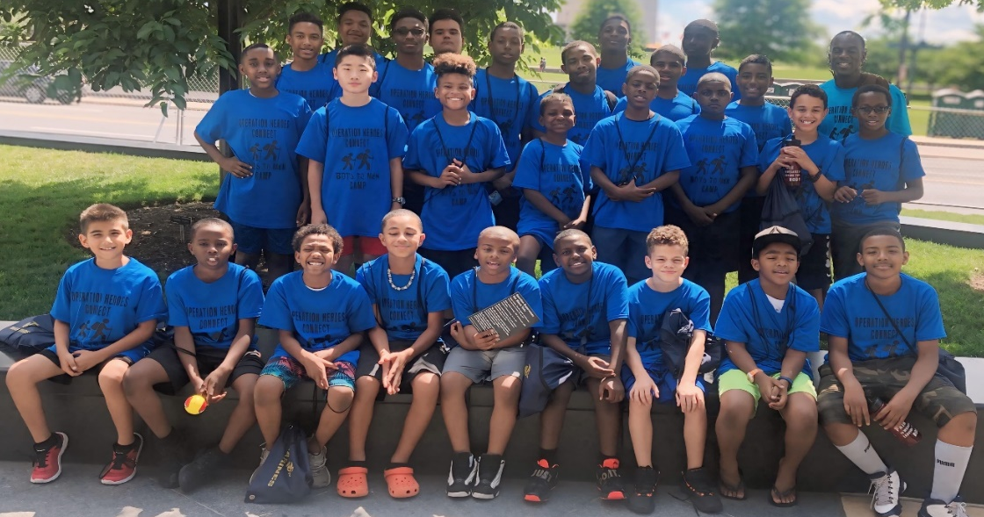
Operation Heroes Connect is a recognized IRS 501(c)(3) non-profit organization, and all donations are tax-deductible to the fullest extent allowed by law.

We are proud to have received esteemed accolades in publications such as Newsweek magazine, The Examiner, The Washingtonian, and Channel 7 News. Our organization was also honored as our founder received the Washingtonian of the Year, which is a true testament of our unwavering commitment to serving the communities of Maryland, D.C, and Northern Virginia. We are privileged to enjoy the endorsement and support of local military bases, to include Marine Corps Base Quantico, VA, Fort Belvoir Army Base, VA, and Patuxent River Naval Base, Solomons, Maryland who recognize the profound impact of our camp program on the lives of young people.
Thank you for your interest in becoming a facilitator. Together, we can make a meaningful difference in the lives of children in our community and provide them with the support and opportunities they need to thrive. If you have any additional questions, please do not hesitate to contact us at operationheroesconnect@gmail.com. We are excited about the possibility of partnering with you and sharing the transformative impact of your support with our campers and their families.
Operation Heroes Connect
As Featured in….

